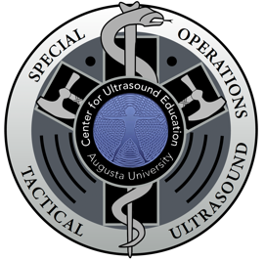
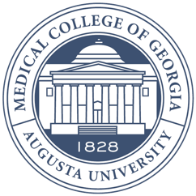
Augusta University

Medical College of Georgia

Center for Ultrasound Education

Things to do around Augusta

Workout Options

Hammonds Ferry Park/Dock
Walk toward river from hotel, turn right
Great outdoor grassy area for bodyweight
workouts, paved running path along
river 14-mile round trip length.

Canal Trail
15 miles, scenic dirt bike/run/walk path
Park and enter across from CSRA Humane Society
425 Wood St Augusta, GA
https://augustacanal.com/about.php

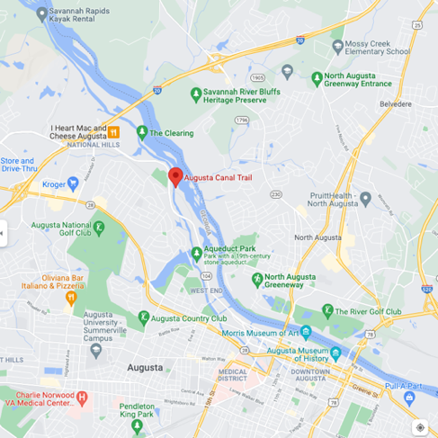
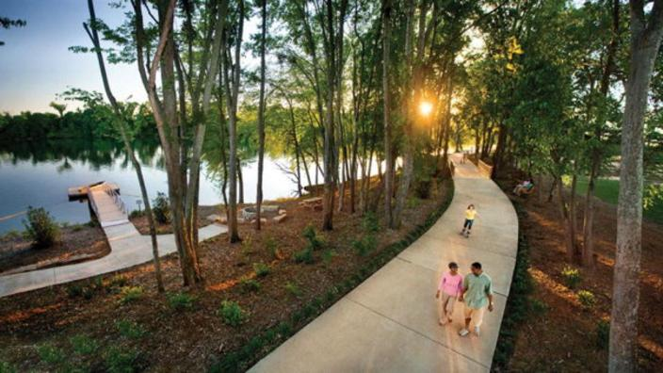

Augusta Aquatic Center
25m swim lanes (closes at 8p) Cost 4$
Damascus Rd, Augusta, GA
Stars and Bars CrossFit
619 E Robinson Ave, Grovetown, GA
20-mile drive, but great gym

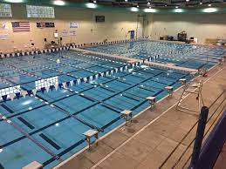
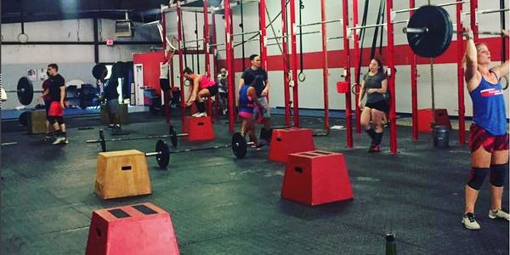

YMCA, Golds Gym, Planet Fitness, Anytime Fitness
All close drive from Hotel in North Augusta, need to be members

Places for Food/Drinks
Southbound Smokehouse (closed Monday & Tuesday)
Across from hotel, SW corner of baseball stadium
1009 Center St North Augusta, SC

Solé (half price sushi on Monday)
1033 Broad Street
Augusta, GA

Broad Street, Augusta GA
Walkable with a number of bars & restaurants
Stillwater Taproom, Whiskey Bar, Edgar’s Rooftop are good spots
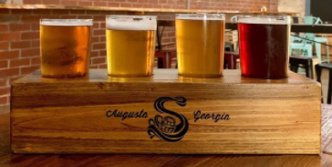
Savanah River Brewing Company
813 5th St Augusta, GA

Riverwatch Brewery
1175 4th St Augusta GA
*Not open on Tuesday

Rio Cantina
Across from Hotel, good food and awesome margaritas

Other things to Do
TopGolf
437 Topgolf Way
Augusta, GA

NorthSide Lanes (Bowling)
1745 Georgia Ave
North Augusta, SC

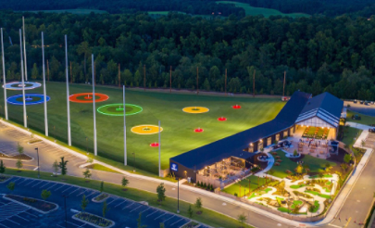

North Augusta Park
Tennis and Basketball- if interested let me know, I have racquets you can borrow.

2nd and Charles
Large, quirky, book, music, games tore across the parking lot from Hooters
2834 Washington Road, Augusta, GA

Richmond County Library (closes 8p)
823 Telfair St, Augusta, GA

