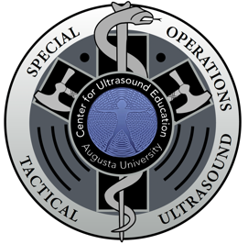
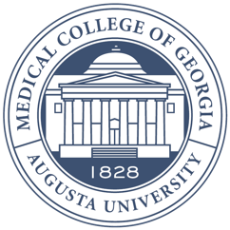
Augusta University

Medical College of Georgia

Center for Ultrasound Education

Helpful Information
- A map is enclosed that gives you a layout of our location, parking and lunch locations.
- Ultrasound Center – 3rd floor of Pavilion 3, suite 3101
- Cafeteria – Across the crosswalk on 2nd floor of hospital
- Student Center Cafe – Adjacent to the parking area
- Einstein’s – 1st floor of the Education Commons

- Badges should be worn at all times.

- Important Phone Numbers
  - Matt Lyon – 706-533-2936 Cara Jones – 706-589-2272
  - AU Police – 706-721-2911 (emergency)

- QR Code for SOTUS Course:
